Luke Bernfeld

10/13/14

I’m a Girl Tee

The socially constructed nature of boy and girl colors typically ends up identifying masculine colors as blue and red, while colors like pink and purple become feminine. These societally constructed normative standards adversely affect little children far too much. So, as a response, I propose making a superhero tee that would flash the words, “I AM A GIRL” across the front of the tee. This is in reaction to a personal issue where my daughter is often mistakenly identified as a boy because she enjoys wearing superhero shirts. The typical colorings of superhero logos, as well as the logos themselves, are labeled as masculine. Thus, the assumption is that individuals wearing these logos must be boys. The piece is designed for my daughter to wear, but is also a protest piece designed as a deconstruction of the gendered norm revolving around clothing.

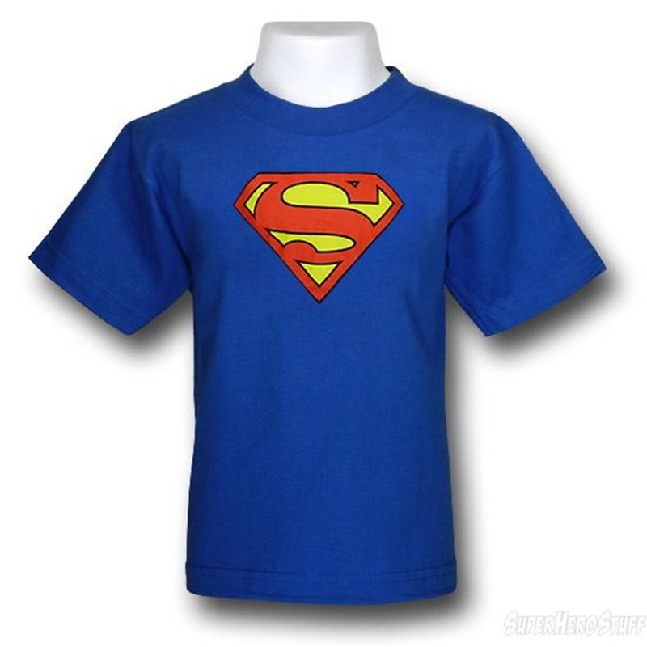

The shirt will be some variation of the superhero variety that falls into the masculine gendered category, similar to the example above. In order for the shirt to display the words, “I AM A GIRL” across the chest, a button in the sleeve or bottom of the shirt is pressed to activate the LED lights.

Supply List

* LilyPad Button Board
* LilyPad Arduino Simple Board
* Red or Blue LEDs
* Thin Conductive Thread
* Shirt Fabric
* Thread
* Superhero Themed Fabric

Weekly Schedule

1. Buy fabric, and order components
2. Design shirt and design LED circuit
3. Program and test circuits
4. Program and test circuits
5. Sew together shirt
6. Assemble circuits in shirt
7. Assemble circuits in shirt
8. Assemble circuits in shirt
9. Final testing and polish

I anticipate that the assembly of the shirt to be more difficult than the programing of the LED message. The LEDs will also be difficult to arrange in the shirt to be able to display the message and finding a way to keep the LEDs safe and functioning will present another challenge. That being said, however, I do not foresee either of these things being overly debilitating.